Setup and Configuration of iLabs ELVIS Version 1.1

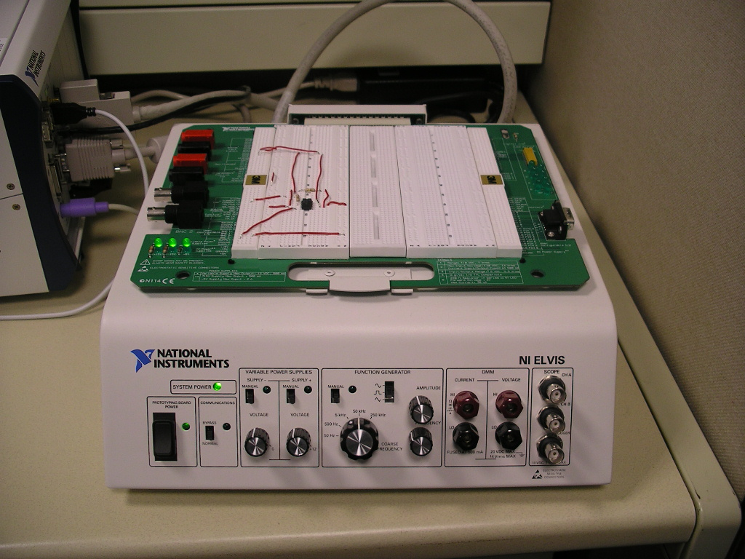

Author: Bryant Harrison - bryant_h@mit.edu
Edited by: James Hardison - hardison@mit.edu
A. Install SQL Server, Service Broker, and Microsoft Visual Studio .NET

Directions for these installations are in the document iLabs Service Broker Machine Build 6.1.doc

B. Install National Instruments LabVIEW and ELVIS software

Software and instructions for its installation should be supplied with the ELVIS hardware from National Instruments. LabView must be installed before the ELVIS driver and control programs can be installed.

C. Install Apache Ant

Apache Ant is an automated software compilation tool and will be used in the following section to compile the Java client for ELVIS. An installation manual should be found in the ant folder under docs\manual\install.html. You need to have the Java SDK installed on your computer and you should put the ant folder on the same drive that has your ELVIS client code

The main instructions to focus on are below. You should run these commands in the command prompt.

Windows and OS/2
Assume Ant is installed in c:\ant\. The following sets up the environment:
set ANT_HOME=c:\ant
set JAVA_HOME=c:\jdk1.2.2
set PATH=%PATH%;%ANT_HOME%\bin

Now any time you make changes to the client you should go to the command prompt, navigate to the client\java directory (usually something like C:\Inetpub\wwwroot\Client\client\java) and type this command:

ant elvis

This should recompile the client and place a new copy in the Client\client\java\jar folder.

D. Install and Configure ELVIS Lab Server and Client Software

In this section, the installation and configuration of the client/server components for making your ELVIS test station available using the iLab Shared Architecture. If you have not completed all of the previous steps, please do so before progressing.

The ELVIS iLab source code is primarily divided into Lab Server and Client code. This document assumes that the ELVIS iLab source code is located at c:\elvisilab. Further it is assumed that the Lab Server code is located in the \labserver subdirectory and the Client code is located in the \client subdirectory.

The following subsections detail major steps in the setup and configuration of this software and should be performed in the order presented.

a. Database Setup
The database structure for the ELVIS iLab Lab Server can be built using the script located at \labserver\database\ELVIS DB Build Script.sql. This script builds the database tables as well as stored procedures used by other portions of the Lab Server and inserts some information to define the initial state of the system. To run the script, open the Query Analyzer utility. This should have been installed as part of the Microsoft SQL Server installation and can be found in its program folder. Open the build script in the Query Analyzer and click on the Run button. Execution of the build script may take up to a few minutes.

As of this writing, execution of the build script may generate errors relating to constraint check failures. If this occurs, open the Microsoft SQL Server Enterprise Manager and delete the database created by the script (the default name is WebLabServicesLS). Next, return to the copy of the build script open in the Query Analyzer and run it again. In many cases this has been observed to resolve these runtime errors.

Once the script completes successfully, the database for the ELVIS iLab Lab Server should be installed. The remaining step here is to assign permissions to enable the other Lab Server processes to use it.

Specifically, there are two accounts that must be given permission. The first of these is the Windows user account that will be used to run the ELVIS iLab Execution Engine. First, create this user account by opening the Computer Management console (Start -> Control Panel -> Administrative Tools). Using the console create a new user account. This account should be a member of the only the Users and Debugging Users group and should be configured such that the password never expires. Ideally, the local security policy for the machine will be set such that this account can only be used to log on to the console locally. Be certain to make note of this password as it will be needed later in the setup process.

Once the account is created, return to the Microsoft SQL Server Enterprise Manager and click on the Security folder under the local database. Under Security, right-click on the Logins item and select the New Login menu item. In the dialog that appears, you can give the newly created system account permission to use the database. In the name field, specify the name of the account (the “…” button will allow you to browse for the account). Under Authentication, make sure that “Windows Authentication” is selected and that the proper domain for the account is specified. More than likely, the machine domain (listed as the network name of the computer) is the proper selection. In the Defaults section, set the default database to the one created earlier (WebLabServicesLS if you are using the default name). Next, click on the “Database Access” tab and give the new account access to the WebLabServicesLS database using the “public” database role. Once this is done, click on the “Ok” button to commit these changes.

Next, browse to the WebLabServicesLS database in the Enterprise Manager console and look under “Users” for the account we just gave access to. The final step in authorizing this account is to open its properties window (right-click on the account and select Properties) and click on the “Permissions” button. From this window, the account can be given specific permissions for the individual database objects. The account should be given SELECT, INSERT, UPDATE and DELETE permissions on all database tables as well as SELECT or EXEC permissions on all stored procedures/user defined functions that begin with “rpm_”, “rm_” or “qm_” as applicable.

The second account we need to enable access for is that used by the .NET runtime to run the code within the IIS web server. This account should already be created on the machine and will use one of the following names depending on your version of Windows:
- Windows 2000 Server (also non-server versions): ASPNET
- Windows 2003 Server: NT AUTHORITY\NETWORK SERVICE

To enable access for this account on the WebLabServicesLS database, follow the same procedure used with the Execution Engine account. Once completed, the ELVIS iLab Lab Server database should be entirely setup and ready for use by the other components of the system.

b. Execution Engine Build and Configuration
In order for the ELVIS iLab Lab Server to work properly the Execution Engine must be compiled from the source distribution and, optionally, configured to automatically launch with the system. Additionally, for the ELVIS system some minor modifications to the Execution Engine code may be required. This section will guide you through these steps.

The ELVIS iLab Execution Engine is made up of three different components. At the lowest layer is a shared DLL that serves as the driver level interface to the ELVIS hardware. Specifically, this DLL is compiled from the LabView VI’s designed to expose certain functionality of the ELVIS platform for this version of the ELVIS iLab. The source VI’s for this library are located in \labserver\ExperimentSetups\instruments\OpAmpInverter and the compiled DLL is at \labserver\ExperimentSetups\wrappers\OpAmpInverter\LabView.

The second component is a wrapper class that makes the functionality of the compiled LabView VI’s available to .NET based components. This is located at \labserver\ExperimentSetups\wrappers\OpAmpInverter\. It is this method that will require some modification. Open the solution file (OpAmpInverter.sln) for this component in your installed copy of Visual Studio.NET. Within Visual Studio, open OpAmpInverter.vb and go to line 96. This line of code contains an absolute file-system reference to the LabView VI library. This reference should be modified to reflect it’s location on your system. For example, if the ELVIS iLab source has been installed in the c:\elvisilab directory, the proper reference would be “c:\\elvisilab\\labserver\\ExperimentSetups\\wrappers\\OpAmpInverter\\labview\\SharedLib.dll”. No other portion of this file should be modified. Once this change has been made, save the file and re-compile the wrapper class by selecting “Build Solution” from the “Build” menu. This should create a new OpAmpInverter.dll file in the \labserver\ExperimentSetups\wrappers\OpAmpInverter\bin directory.

The third and final component of the ELVIS iLab Execution Engine is the top-level execution engine code itself. This is what retrieves experiment specifications from the lab database and orchestrates their execution via the previously mentioned components. This is located at \labserver\experiment_engine. Since we modified the wrapper class on which this depends, it is recommended that this component be checked for correct reference locations and recompiled. As with the wrapper class, open the experiment_engine.sln file using Visual Studio. In this case, expand the “References” item in the Solution Explorer and view the properties for the OpAmpInverter library. The Path field for this reference should point to the copy of the wrapper class we compiled in the previous step. If not, remove the reference to this file and add a new one pointing to the correct location. In the Add Reference dialog, you will need to browse for it and add it as a .NET library. Once this is complete, re-compile this solution (“Build Solution” under the “Build” menu). This will create a new copy of the file “experiment_engine.exe” at \labserver\experiment_engine\bin. This is the executable that must be run in order for the Execution Engine to perform experiments.

Of course, one can run this program by simply double-clicking on it. In fact, this is a good test to make sure all of the previous setup steps have been performed properly. For normal use though, this program has been designed to be launched automatically and run in the background in an unattended fashion. This has benefits over manually running the program in that the user who ran the program does not have to remain logged on to the machine while the program runs.

This automatic launch is accomplished by configuring the program as a Scheduled Task. To set this up, go to Start -> Control Panel -> Scheduled Task and open the Add Scheduled Task wizard. On the page where the wizard asks for the application to be run, browse to the location of the experiment_engine.exe file noted above. On the following page you can assign a name for this scheduled event and specify when you want the program to run. Our recommendation is to set the program to run when the computer starts. After that, you must enter the user account you would like the program to run under. For this, specify the user account that we created for the Execution Engine when setting up the lab database. Both the account username and password will be necessary. On the final page of the wizard, confirm all of your settings and check the option to open advanced properties and then click on the “Finish” button.

In the advanced properties dialog, click on the Settings tab and uncheck the option to stop the task if it runs for a certain amount of time and click on the “Ok” button. The ELVIS iLab Execution Engine is designed to run indefinitely as a background process on the system while consuming a minimum of resources. Once this is has been setup and the Execution Engine is confirmed to start on its own properly (restart the computer and look for the “experiment_engine.exe” process in the Task Manager) the system will be ready to perform experiments on the ELVIS hardware.

c. Web Site Setup
The final component to be setup in the ELVIS iLab Lab Server is the Web Site. This is where the Web Service interface to this instance of the ELVIS iLab as well as its administrative functions will be published. To do this, open the Microsoft IIS console at Start -> Control Panel -> Administrative Tools -> Internet Services Manager. The first step is to stop any services that are setup and running by default. This includes any default FTP, SMTP, NNTP or web sites that you are not using. Please note that if you are also installing a Service Broker on this machine, it will need the default SMTP server enabled. These items can be stopped and started by right clicking on them in the IIS console and clicking on the appropriate menu item.

Next, the web site that will host the Lab Server web components can be built by right-clicking on the machine icon on the left side of the IIS console and selecting “Web Site” under the “New” item. This will launch the Web Site Creation Wizard. Here you must first specify a title for the site. This will be used for the IIS console listing and will not be visible on the web site itself. The next page allows you to set IP address and port settings. Typically, leaving the default value for the IP address (“[All Unassigned]”) will be sufficient. Exceptions to this will be if you have two network interfaces on your server and want to host the site for traffic from only one of them. The TCP port should be left at the default value of 80 unless you are hosting other web sites on this system. While the ELVIS iLab Lab Server can be hosted on other ports, these instructions assume the use of port 80. Finally, leave the host header field empty and click on the “Next” button.

On the following page you will be asked indicate the location of root directory for the web site. This is the \labserver directory of the ELVIS iLab source. Browse to this directory and select it as the home directory path. Make sure anonymous access to the site is enabled and click on the “Next” button. The next page will ask you to specify access permissions for this web site. The default values of Read and Run scripts should be enabled. Other permissions are not required by the ELVIS iLab Lab Server but may be enabled at your discretion. Once you have made your selections, click on the “Next” button and complete the creation process. At this point, the new site should be listed on the left side of the IIS console.

After the site is created, we will need to fine tune some settings. Right-click on the newly created web site and open the Properties dialog. On the “Documents” tab, add a new default document listing for “index.aspx” and move this to the top of the list using the arrow buttons on the dialog. Commit these changes by clicking on the “Ok” button and make sure your new web site is running (if it is not running, its status will be noted in parenthesis next to its name in the IIS console). At this point, the web site should be completely set up. Test this by opening a browser window and directing it to your server. If any of the pages show up incorrectly, certain page or image links may need to be edited to reflect your specific directory structure. These file are located in the \labserver and \labserver\admin directories. Also, proper operation of the web site indicates that the ELVIS iLab Lab Server components run within the Web Server are accessing the database as intended. Double-check the availability of the Web Services interface by browsing to the /services/WeblabService.asmx page on your web site.

Once the Lab Server web site is properly setup, there is some initial setup that will need to be done. Browse to the web site home page and log in using the credentials for the default administrator account (username: admin, password: mrroot). Once logged in, go to the Configurations Settings page. The Web Service Interface and Execution Engine should be set to “Enabled”. Also, fill in the web site URL in the System URL field. This should be the address used to browse to the web site login page (ex: http://foo.bar.edu). For each of those fields, commit your changes by clicking on the “Update” link next to the field. Finally, this page also allows you to set/view the Lab Server’s unique ID. This is the server ID used to identify the server to Service Brokers and clients in the iLab network. If you just set this system up, there should be a “Generate New ID” link in the System ID field of this page. Click on this to generate and save this Lab Server’s ID. From this point forward, this value can only be viewed from this page.

You may also change the password for the default administrator account or add new accounts at the “Site Users” page on this interface. Following sections will describe how to define experiment setups as well as how to register this lab with Service Brokers on the iLab network.

d. Client Build
Source code for the MIT ELVIS iLab Lab Client is included with the lab distribution. This may be used as a whole or as a basis for developers who wish to create a customized version. In order to use the client as packaged, it must be compiled, packaged into a JAR file and hosted by your Service Broker’s web site.

The first two-thirds of this will be performed using the build file included with the client source and the Ant program discussed earlier. If you have not yet installed Ant, you must do so in order to complete this step.

The ELVIS iLab Client build file is located in the /client/java directory. In order to build the ELVIS client, open a command prompt and go to this directory. Type the following command to build the client:

ant elvis

Execution of this command should result in the display of a number of status messages describing the compilation and archiving process along with the final indication of success or failure. The build process will create a /jar folder in the /client/java directory. The compiled client JAR file will be located in this folder and will be titled ELVIS-client.jar.

In order for users to use the lab, this client JAR file must be hosted on your Service Broker’s web site. That is, users must be able to download the JAR file from the same Service Broker they are using to access the lab. This file can be placed in any directory on the Service Broker web site as long as it is publicly accessible (the configuration instructions below assume that it is placed in the /jar folder under the Service Broker root web directory). Once the JAR file is copied to its final location, confirm its availability by browsing to its web URL. Make note of this URL as it will be used as the “archive” location when setting up the Lab Client record on the Service Broker in the next section.

E. Configure Lab Server and Service Broker

Overview: This portion of the document is intended to outline the process of putting an experiment online and registering a service broker, lab server, and client for the first time. Specific portions may be helpful in adding or modifying experiment setups later, or registering more service brokers, servers, and clients in the future.

There are two main pages that you will use in the administration of iLabs.

Lab Server Management (LSM) page: http://localhost/LabServer/index.aspx
Default Username: admin
Default Password: mrroot

Service Broker (SB) : http://localhost/ServiceBroker/
Default Username: superuser
Default Password: ilab
*Note: Any user that is a member of the superuser group has administrator priveledges

1. In LSM go to System Status→Configuration Settings

Lab Status Settings section:
- WebLab Web Service Interface: Enabled
- Click “Update”
- Experiment Execution Engine: Enabled
- Click “Update”
*Note: “Update All Lab Status Settings” does not work

Configuration Settings section:
- Click “Generate New ID”
- Record this Server ID for future reference

2. Create a new experiment setup: Go to Experiment Setup Management→Experiment Setups

- Click “Create New Setup”
- Enter a name, image (e.g. schematic), and description for the experiment
- Click “Create Setup” and you know have an option to “Add New Terminal”
*Note: A terminal is an ELVIS device, and currently the options are “FGEN” (function generator) and “SCOPE” (oscilloscope). You should use each device.
- Fill out the form for an FGEN with appropriate values. Pixel locations are where the devices should be connected to the image.
- Click “Create terminal”
- Repeat steps for SCOPE terminal

3. Activate the experiment: Go to Experiment Setup Management→Active Setups
- Click checkbox next to experiment to activate it. An active experiment will be available to the user in the client
- Click “Commit Assignment”

4. Go to SB as an administrator and go to Lab Servers & Clients→Manage Lab Servers
- Complete the form:
  - Lab Server Name: <enter name>
  - Lab Server GUID: This is the Server ID (found in LSM page, System Status→Configuration Settings)
  - Web Service URL: http://yourlabservername/LabServer/services/weblabservice.asmx
  - Description: <enter description>
  - Lab Info URL: <enter url if you have a page that contains lab info>
  - Contact First Name, Last Name, Email: <enter info of lab administrator>

- Click “Go” for Generate New Incoming Passkey. This is the “Lab Server Passkey” that will be used in Step 5.
- Click “Save Changes” and leave this page open.

5. Create a broker. On the LSM page, go to Accounts→Broker Management
- Click “Create New Broker”
- Complete the form:
  - Name: <enter name>
  - Usage Class: Guests
  - Description: <enter description>
  - Broker service URL: http://yourservername/ServiceBroker/services/servicebrokerservice.asmx
  - Contact First Name, Last Name, Email: <info of administrator>
  - Broker ID: <copy from Service broker’s web.config file. This is the service broker ID>
  - Lab Server Passkey: This is the “Incoming Passkey” that the SB generated in Step 4.

- Click “Create Service Broker” and a “Broker Passkey” will be created. This will be used in Step 6.

6. Check Usage Class permissions: In LSM go to Access Control→Usage Classes
- Click “Guests”
  - Check all boxes for “WSInterface” and “Setup Management” resource.
  - Check “View” and “Grant” boxes for any of the experiment setups listed in the “Resources” column

7. In the SB Manage Lab Servers page
- Fill out the “Outgoing Passkey” for your server with the “Broker Passkey”.
- Click “Save Changes”

8. In the SB, go to the Lab Servers & Clients→Manage Lab Clients tab
- Complete the form:
  - Lab Client Name: <enter name>
  - Version: <enter version #>
  - Short Description: <enter short description>
  - Long Description: <enter long description>
  - Contact First Name, Last Name, Email: <enter info of lab admin>
  - Documentation URL: <Enter if have documentation of client>
  - Notes: <enter if have notes>
  - Client Type: Applet Client
  - Loader Script:
<APPLET
height=50 width=100
archive="http://localhost/ServiceBroker/jar/ELVIS-client.jar"
code="weblab.client.graphicalUI.GraphicalApplet"
ALT="This is ALT text. Couldn't load the applet.">
<PARAM NAME="serviceURL" VALUE="http://localhost/ServiceBroker/Services/ServiceBrokerService.asmx">
<PARAM NAME="labServerID" VALUE="59de99d2742f483cad530c2b52a35568">
<PARAM NAME="helpURL" VALUE="http://localhost/">
This is alternateHTML. Couldn't load the applet.
</APPLET>

*Note: change the bold information to reflect the actual location of those files on your servers. Also the labServerID should be changed to what the Lab Server ID is (See Step 1 or Step 4)

- Click “Save Changes”

9. In SB, Lab Servers & Clients→Manage Labs
- Select the client you will use
- Under the “Available” category select any group you want to use the lab and Click “Add”.
*Note: You can create and administer a group in the SB “Users & Groups” tab
- Click “Save Changes”

10. In SB, go to Grants
- Under “Users and Groups” click the group you want to grant access to a lab
- Under “Functions” click “useLabClient”
- Under “Qualifiers” click <name of client>
- Click “Add Grant”
- Under “Functions” click “useLabServer”
- Under “Qualifiers” click <name of server>

You are done!

